Homework 3: NYC Taxi Analytics with PySpark
EC2 Setup
This assignment was completed using an AWS EC2 instance running Amazon Linux 2023 in the us-east-1 region, using PySpark to complete all data processing and analysis. The environment was configured with Java, Python, PySpark, Pandas, PyArrow, Matplotlib, and AWS CLI, while data was downloaded and outputs were stored on S3 buckets. Data was stored locally in EC2 before being loaded into Spark DataFrames. The development environment was Jupyter Notebook through an SSH tunnel. The analysis was performed on an AWS EC2 t2.large instance, which provides 2 vCPUs and 8 GB of memory, comfortably allowing the processing of several million taxi trip records.
Dataset Description
The data analysis homework was based on NYC Taxi and Limousine Commission (TLC) trip records for January 2026. There were two distinct datasets used – one for yellow and the other for green taxis. Although the yellow and green taxi datasets had slightly different schemas, particularly in their pickup and dropoff timestamp column names, the key fields were standardized to a common schema to enable consistent analysis and comparison across taxi types. Relevant fields include trip distance, pickup and dropoff times & locations, and fare amounts.
Initially, the yellow taxi data had 3,724,889 records while the green taxi data had 40,272 records.
Data Cleaning
The following cleaning rules were applied to the datasets post standardization:
- Remove rows with missing pickup or drop-off timestamps.
- Remove trips with non-positive distance.
- Remove trips with negative fares.
- Remove trips with negative total amount.
- Remove trips longer than 24 hours.
- Remove trips with drop-off time before pickup time.
The following was the change in number of records post cleaning:
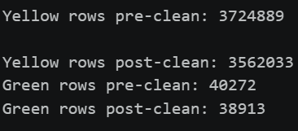

Analytic Questions
Question 2: What was the average fare by taxi type?
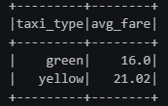
Question 3: What was the average trip distance by taxi type?
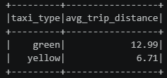
Question 4: What hour of day had the most pickups?
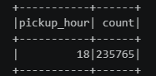
Question 5: What percentage of trips were under 2 miles?
Question 8: Predict the fare amount using non-fare predictor columns.
Predictor Importance Analysis: The Random Forest model identified trip distance as the most important predictor of fare amount, with an importance score of 0.8371. This result is expected because taxi fares are primarily determined by the distance travelled, making trip distance the strongest driver of pricing. The second most important predictor was pickup location, with an importance score of 0.1110, indicating that fares vary across different pickup zones due to differences in travel demand and trip patterns. Other location-based information, such as drop-off location, also contributed to the model but with substantially lower importance. In contrast, variables such as passenger count, pickup hour, pickup day of week, and taxi type had very small importance scores, suggesting that they provided relatively little additional information for predicting fare amount. Overall, the results indicate that fare prediction is driven primarily by trip distance, while location-based variables provide secondary predictive value.
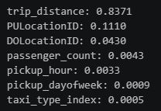
Model Accuracy
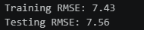
The Random Forest model resulted in a training RMSE of 7.43 and a testing RMSE of 7.56, indicating that the model performed well on unseen data with minimal overfitting and was able to predict taxi fares with an average error of around $7.50 per trip.
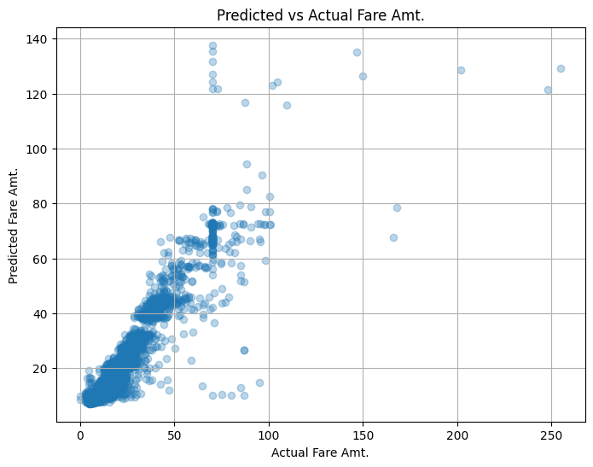
S3 Outputs
Results tables and plots were written to this S3 bucket.
s3://yash-hw3/nyc-taxi-assignment/
The files generated were:
average_fare_by_taxi_type/
average_distance_by_taxi_types/
pickups_by_hour/
predicted_vs_actual_fare.png
AI Tools
ChatGPT was used to help with downloading and uploading files from and to S3. It was also used to help get context for how to use PySpark SQL based functions.

